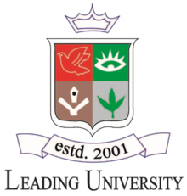

**LEADING UNIVERSITY, SYLHET**

Dept. of Computer Science & Engineering

**Lab Report**

Course Code: ***EEE - 3212***

Course Title: ***Microprocessor Assembly Language and Computer Interfacing Sessional***

**Submitted To:**

Shadman Sakib

Lecturer,

Leading University, Sylhet.

**Submitted By:**

*Md. Rishad Al Jubair Talukder*

*Id: 2012020264*

*Sec: F*

**Submission Date**

*27.11.22*